High Level Design (HLD)

E-Bus Management Based Current Location System

Revision Number: 2

Last date of revision: 06/09/2023

Abutalha D Maniyar

# Document Version Control

|  |  |  |  |
| --- | --- | --- | --- |
| Date Issued | Version | Description | Author |
| 05th September 2023 | 1.1 | First Draft | Abutalha Maniyar |
| 06th September 2023 | 1.2 | Second Draft | Abutalha Maniyar |

**Contents**

Document Version Control ii

1 Introduction 2

1.1 Why this High-Level Design Document? 2

1.2 Scope 2

2 General Description 2

2.1 PROBLEM STATEMENT 3

2.2 PROPOSED SOLUTION 3

2.3 FURTHER IMPROVEMENTS 3

2.4 TECHNICAL REQUIREMENT 3

2.5 Data Requirement 3

2.6 Tools Used 3

2.7 Constraints 4

2.8 Assumptions 4

3 Design Details 4

3.1 Process Flow 4

3.2 Deployment 5

3.3 Event Log 5

3.4 Error Handling 5

4 Performance 6

4.1 Reusability 6

4.2 Scalability and Load Handling 6

5 Conclusion 6

**Abstract**

Advanced traveller information systems are one component of intelligent transportation systems, and a major component is travelling time information. It is a very important subject to improve the precision and reliability of the bus management model which can attract additional ridership, reduce passenger’s anxiety and waiting times at bus stop, and increase their satisfaction. Furthermore, it can promote the development of city public transportation. This paper presents an improved approach to know the public bus arrival time based on the bus dashboard provided by the driver. Hence helps both the users and the agency at the same time.

# Introduction

## Why this High-Level Design Document?

The purpose of this document is to present a detailed description of the E-Bus Management Based Current Location System. It will explain the features of the system, the interfaces of the system and what the system will do. This document is also intended to help detect contradiction prior to coding, and can be used as a reference manual for how the module interact at high level.

The HLD will :

* Present all the design aspects and define them in detail
* Describe the user interface being implemented
* Describe the hardware and software interfaces
* Describe the performance requirements
* Include design features and the architecture of the project
* List and describe the non-functional attributes like:
  + Security
  + Reliability
  + Maintainability
  + Portability
  + Reusability
  + App compatibility
  + Resource utilzation
  + Serviceability

## Scope

* The HLD documentation presents the structure of the system, such as the database architecture, application layers, application flow (navigation), and technology architecture.
* The HLD uses non-technical to mildly-technical terms which should be understandable to administrators of the system.
* This software system will be a Web application, this system will be designed to overcome the drawbacks of the present system and to make the travel experience better and easy.
* It aims to provide comprehensive bus information, including expected arrival times and waiting times, while also facilitating efficient management of public transport buses.
* Additionally, it will serve as a platform for private agencies to manage their services online and offer a common platform for all users to access bus-related information.

# General Description

## 2.1 PROBLEM STATEMENT

One component of intelligent transportation systems is advanced traveller information systems, with trip time information being a prominent component. Many transit agencies use the Prediction Model to watch their cars and forecast journey times in real time. It is critical to improve the precision and reliability of the prediction model in order to increase ridership, reduce passenger anxiety and wait times at bus stops, and improve passenger satisfaction. In addition, it has the potential to stimulate the growth of local public transportation. This study introduces a new method for predicting the arrival time of a public bus based on its location. The bus arrival time and linger time at prior stops are chosen as the key input variables after a thorough examination of the components of bus arrival time.

## 2.2 PROPOSED SOLUTION

The Ebus Management Based Location System aims to transform the public transportation sector by providing passengers with a seamless and efficient bus service experience while enabling public transport authorities and private agencies to manage and optimize their services effectively.

## 2.3 FURTHER IMPROVEMENTS

E-bus system can be added with more use cases like ticket booking, bus reviews. Recommendation system can be built on top of it to provide users with best vacation plans.

## 2.4 TECHNICAL REQUIREMENT

To use the system technical requirement is web browser. In some cases, the requirements could be the credentials.

## 2.5 Data Requirement

However, data requirement completely depends on our problem statement

* We need name of the cities
* Bus information, Driver information

## Tools Used

Python programming language and web framework flask.

IDE : Visual Studio Code (VS Code)

MongoDB Atlas : for remote database

MongoDB Compass : to access the database

## Constraints

* Security measures will be in place to protect user data and system integrity.
* Compliance with relevant regulations and standards in the public transportation sector.

## Assumptions

* Hardware Compatibility: Users' devices, including smartphones, tablets, and computers, are assumed to be compatible with the BIMS web and mobile applications.
* The system's scalability assumptions include the ability to handle increased user traffic and data volumes as the user base grows.
* The accuracy of real-time bus tracking and bus-related data is assumed, as discrepancies in data quality could impact the system's reliability.

## Design Details

## Process Flow

Below given is all the process flow that should happen in the application

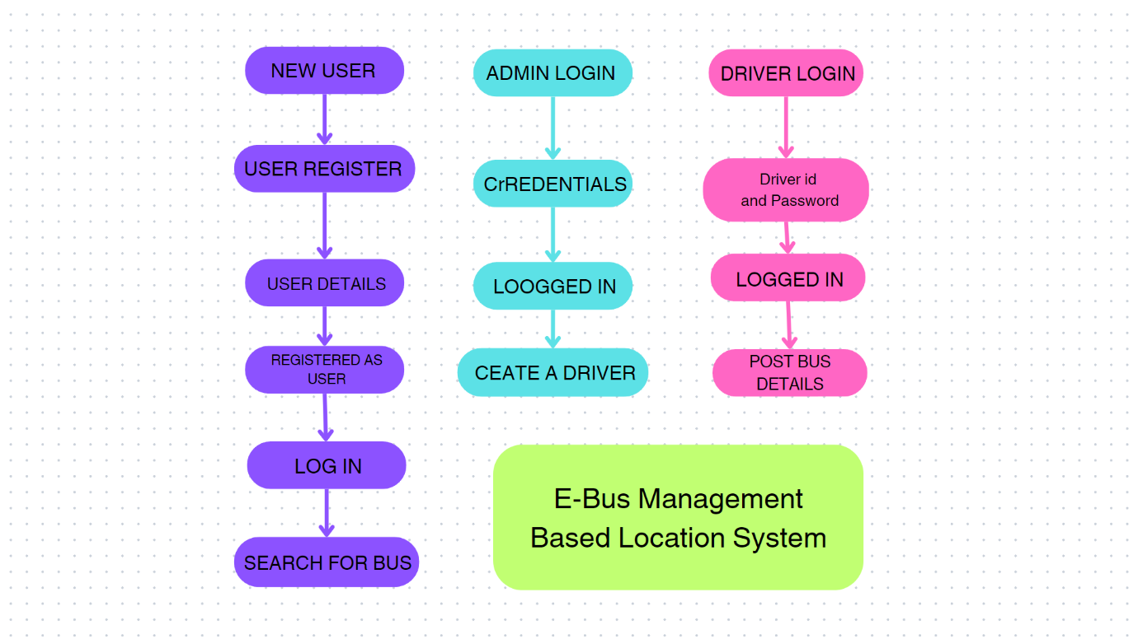

* 1. **Deployment**
* Deployment on cloud infrastructure (i.e., AWS) for scalability and availability.
* Continuous integration and continuous deployment (CI/CD) pipelines for automated updates.

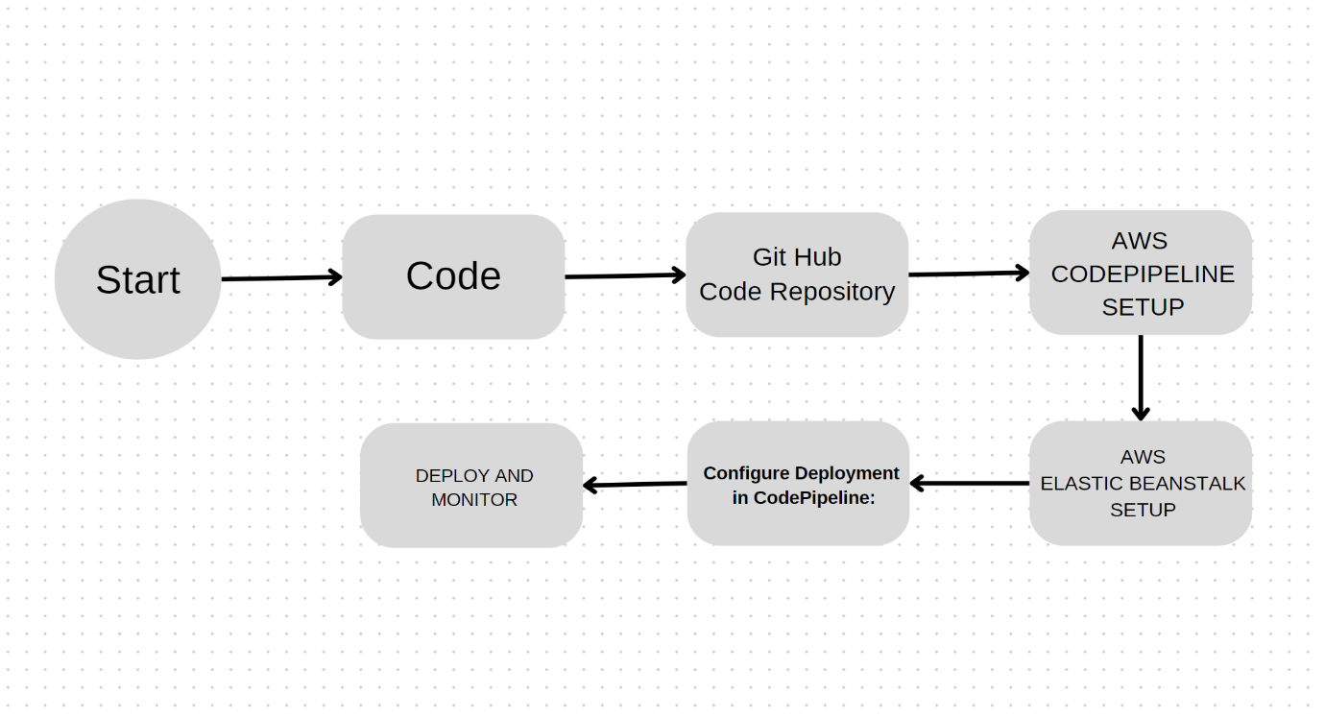

AWS EBS CODEPIPELINE

## 

## 3.3 Event Log

* The System identifies at what step logging required
* The System should be able to log each and every system flow.
* Developers can choose logging methods. You can choose database logging/ File logging as well.

## 3.4 Error Handling

Errors should be encountered an explanation will be displayed as to what went wrong? An error will be defined as anything that falls outside the normal intended usage.

## Performance

Performance of the Bus Information and Management System (BIMS) can significantly impact the user experience and the efficiency of public transportation services. Here are three key points regarding its performance:

## Reusability

The code written and the components used should have the ability to be reused with no problems.

## Scalability and Load Handling

BIMS is architected to scale horizontally to accommodate increasing user traffic and data volume as the user base grows. It leverages cloud infrastructure to provide elasticity and handle spikes in usage.

The system's ability to scale ensures that it can handle the demands of a large urban population and multiple private transport agencies without compromising performance.

## Conclusion

In conclusion, this system represents a transformative solution that addresses the existing challenges and limitations of the current public transportation systems. By focusing on real-time responsiveness, scalability, and reliability, it aims to enhance the overall public transportation experience for passengers and streamline bus management for administrators.

Passengers have access to the information and hence reduce waiting times, and ultimately improve their journey experience. Simultaneously, administrators benefit from real-time data to optimize bus deployment, maintenance, and scheduling, leading to more efficient public transportation services.

The system's scalability and load-handling capabilities ensure that it can grow and adapt to meet the needs of urban populations and accommodate multiple private transport agencies. This scalability is made possible through cloud infrastructure and load-balancing strategies, providing elasticity and robust performance during peak usage.

In essence, E-bus System serves as a modern and holistic solution for improving the management and accessibility of bus-related information and services. By focusing on performance and user experience, it plays a vital role in enhancing the efficiency and convenience of public transportation systems. Through continuous refinement and adaptation, it can contribute to more sustainable and user-centric transportation solutions, ultimately benefiting communities and passengers alike.